WORLD-CHANGING CHEMISTRY INQUIRY COMPETITION
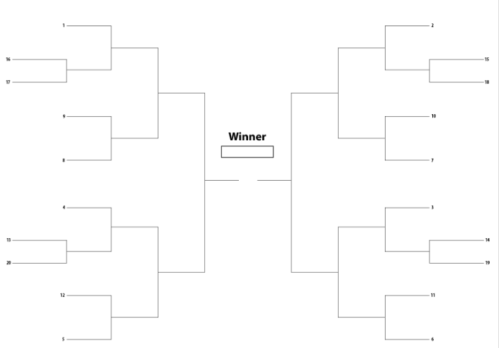

Convince your classmates how an element, molecule, chemist, or chemical experiment has changed, is changing or will change the world.

Each of you will choose an element, molecule, chemist or a chemical application and research the impact it/they has had on the world. The impact may be historical or current. Whichever you choose the impact must be world-changing! After researching, you will create a presentation where you will share the details of your choice and give evidence as to why it/they changed the world.

Criteria for world-changing:

How will you communicate the importance of your world-changing element, molecule, chemist or chemical application?
You may do this in anyway you see best→ talk with your teacher for confirmation of your plan. If you have no ideas here are some options:
- Create a slideshow (either Google Slides or Powerpoint) that shows the impact.
- Create a video that explains the impact.
- Create a poster and a speech that explains the impact.
- Write a speech with visuals to help your audience understand.
- Create a youtube video that shows the impact.

Battle Royale Playbook
Round 1 & 2: You will have 3 minutes to convince the competition that your selection is the most world-changing. After your 3 minutes, your competitor will have 3 minutes to share their evidence. After that you will use the criteria for “most world-changing” to decide who advances to the next round.
Round 3 & 4: These rounds follow the same rules as Round 1 & 2, but you will have only 2 minutes to convince the competition. You will have to edit yourself and choose the most import stuff to share.
Final Round: You have made it to the final bracket! Now you have a team of classmates that are convinced that your selection is the most world-changing. You will work with this team to come up with new information for a final 1 minute blast attack on your opponent. During this final 1 minute, the information shared must be new with new visuals.
How you win a round: 2 of your classmates will watch your round. They will decide which selection is the most world-changing. If they can’t decide, you get 1 more minute for a blast attack to make your case.

Assessment:
Your teachers will be observing you during the research portion and competition days and will be collecting evidence on the following three competencies, using the scale of Acquiring, Developing and Mastering. (Please note that the persuasive portion of the assessment will be shared with Mr. Schmalz for him to include in your English grade.)
Competency | Acquiring | Developing | Mastering
Use scientific understandings to identify relationships and draw conclusions | At a beginner level, teacher support and direction needed | Learning to practice and apply the skill with some teacher support | Consistently and independently demonstrates competence in applying skills
Communicate ideas, findings, and solutions to problems using scientific language and representations and digital technologies | At a beginner level, teacher support and direction needed | Learning to practice and apply the skill with some teacher support | Consistently and independently demonstrates competence in applying skills
Express an opinion and support it with credible evidence  (this part will be shared with Mr. Schmalz) | At a beginner level, teacher support and direction needed | Learning to practice and apply the skill with some teacher support | Consistently and independently demonstrates competence in applying skills

GENERAL STEPS

NEED: choose an element, molecule, chemist or chemical experiment and describe how it is used in the world

MUST: explain how it/they has an important impact in the world

CAN: be persuasive and give scientific evidence to support the world-changing criteria

COULD: use detailed scientific evidence and convincing language to support your claim that it is the most world-changing

